Wiley

Advances in Human-Computer Interaction Volume 2024, Article ID 9921363, 19 pages https://doi.org/10.1155/2024/9921363

*Research Article*

The Impact of Artificial Intelligence Applications on Digital Banking in Turkish Banking Industry

# Serkan Demirel1 and Murat Topcu 2

*1Department of International Trade and Finance, Istanbul Gelisim University, Istanbul, Tu¨rkiye*

*2Department of Customs Business, Istanbul Gelisim University, Istanbul, Tu¨rkiye* Correspondence should be addressed to Murat Topcu; [mtopcu@gelisim.edu.tr](mailto:mtopcu@gelisim.edu.tr) Received 21 August 2023; Revised 16 July 2024; Accepted 17 July 2024 Academic Editor: Ahmad Althunibat

Copyright © 2024 Serkan Demirel and Murat Topcu. This is an open access article distributed under the [Creative Commons](https://creativecommons.org/licenses/by/4.0/) [Attribution License,](https://creativecommons.org/licenses/by/4.0/) which permits unrestricted use, distribution, and reproduction in any medium, provided the original work is properly cited.

This paper presents the effects of chat box (C.B.) and video call (V.C.) artificial intelligence applications, which are becoming increasingly common in the banking system in parallel with the development of information systems on the number of digital banking users, and the relationship between the variables is investigated. The data set of the variables consists of a total of 44 observation points between the 1st quarter of 2012 and the 4th quarter of 2022. The cointegration relationship between the variables is examined using the ARDL cointegration test. According to the F statistic results for cointegration hypothesis testing, there is a statistically significant relationship between the variables at a 1% significance level. In the long run, a 1% increase in Chat Box users causes an increase of approximately 0.2% in the number of mobile banking users. A 1% increase in Chat Box users in the short term increases the number of mobile banking users in the current period by approximately 0.03%. A 1% increase in video call users in the long term causes an increase of approximately 0.04% in the number of mobile banking users. A 1% increase in the number of video calls in the current period increases current period mobile banking applications by approximately 0.005%. It has been determined that the effect of chat box applications on mobile banking is higher than that of video call applications. In addition, there is a close correlation between mobile banking and the independent variable chat box, no correlation between mobile banking and video calling, and a moderate correlation between chat box and video calling. All findings mean that artificial intelligence applications positively contribute to the expansion of mobile banking.

# Introduction

Rapid developments in technology and the digital world in the last thirty years have led to significant changes and transformations in the economic and financial fields. The adaptation, internalization, or rejection behaviors of tech- nological developments and new applications also differ between generations. With new generations growing up with technology, the rate of access to technology by the middle class and the increase in the number of active users in social networks have drastically changed the business environment and the way firms do business [1], p. 28. The focal point of change and transformation is the upgrading of old products or services, the addition of newer models, and the use of systems with artificial intelligence in the production of

products and services. In this framework, companies’ tradi- tional marketing strategies and systems have had to transform into a digitalized modern marketing approach in which big data is processed. Firms have become more “connected” with their customers through digital platforms and the Internet. The main reason for this is social media’s popularity and the rapid spread of smartphones to the lower layers of society [2],

p. 12. In this context, the study focuses on the impact of technological developments in the banking sector and in- dividuals’ widespread use of artificial intelligence applications in mobile banking. In this context, the number of chat box (C.B.) and video call (V.C.) users indicates the spread of artificial intelligence applications in the banking sector.

As the rate of adaptation of large layers of societies to the digital age has increased, there has been a tendency towards

2 Advances in Human-Computer Interaction

singularity in individuals and towards technologies that can produce services and products that can operate self-decision processes called “artificial intelligence” in companies. Ar- tificial intelligence, one of the most important inventions of the 21st century, has started to change the consistent evo- lutionary model of the science and technology world and the future of societies. Personal data held by companies and the transformation of these data into personalized customer experience have made data storage and processing processes necessary. The excessive increase in digital services has paved the way for the formation of “big data,” giant piles of in- formation that average human intelligence cannot over- come. At this point, artificial intelligence applications have started to help process big data and transform it into helpful information that companies can use in marketing.

3637, 2024, 1, Downloaded from https://onlinelibrary.wiley.com/doi/10.1155/2024/9921363 by Lovely Professional University, Wiley Online Library on [09/09/2024]. See the Terms and Conditions (https://onlinelibrary.wiley.com/terms-and-conditions) on Wiley Online Library for rules of use; OA articles are governed by the applicable Creative Commons License

Artificial intelligence is a technology with human-like

intelligence that can use the decision-making processes of computer systems thanks to the software created and manifests itself in many areas. Within the scope of the study, artificial intelligence applications in banking are effectively used in many areas, such as improving customer experience, increasing operational efficiency, strengthening security measures, improving risk management, and strengthening marketing strategies. In terms of customer experience, ar- tificial intelligence enables banks to offer a more interactive customer experience. Getting fast and accurate answers through chatbots and efficiently performing bank trans- actions with AI-supported voice assistants is possible. In addition, artificial intelligence algorithms can offer personal financial recommendations by analyzing customer behavior and better understanding customers’ preferences.

The use of artificial intelligence in routine tasks such as

automatic account opening and credit evaluation in oper- ational processes increases banks’ efficiency. Chatbots provide faster and more effective customer support by re- ducing the intensity of customer service. In addition, by undertaking repetitive tasks such as document management, AI-supported robots enable bank personnel to focus on other areas and managers to focus on strategic tasks.

Artificial intelligence applications in the security field help eliminate fraud and security threats, one of the biggest problems of digital banking. Artificial intelligence algo- rithms can automatically detect suspicious activities, strengthen authentication processes, and identify fraud at- tempts. In terms of risk management, artificial intelligence algorithms can predict customer payments by analyzing big data, assessing credit risk, and identifying risky loans. It can also allow banks to create more effective risk management strategies by predicting fluctuations and risks in financial markets. In marketing and customer relationship manage- ment, artificial intelligence applications can offer person- alized products and services to customers by analyzing customer preferences and demands. Customer segmentation and targeting can be carried out more precisely with artificial intelligence-supported marketing strategies in the sector. In the banking sector, artificial intelligence applications and algorithms improve banks’ ability to predict and analyze the future and help shape marketing strategies by predicting future trends and customer demands of banks. Considering

the developments described above, artificial intelligence applications and algorithms are considered to increase the competitive advantage of banks in many areas, such as customer experience, operational efficiency, security, risk management, and marketing strategies by taking digital banking to the next level.

In addition, customers’ privacy and security concerns due to unauthorized access to data in mobile banking can trigger a lack of control over their data. According to Sutanto et al. [3], p. 1142, an increase in privacy concerns signifi- cantly decreases satisfaction and trust levels [4]. This may negatively affect the intention to use and further adoption of mobile banking systems. In the banking system, attention should be paid to ethical rules, privacy, and security issues related to using artificial intelligence. In this context, there are gaps in the sector regarding artificial intelligence ap- plications. For example, there is a need for legal regulations to clearly set out how the audit will be carried out regarding the work, transactions, and processes carried out by artificial intelligence and to whom the responsibilities will belong. Only in this way will it be possible to make the best use of the benefits of artificial intelligence in the banking sector.

The banking sector in Turkey, where A.I. applications

have become increasingly widespread, is a fast-growing segment of financial institutions [5]. The sector has rap- idly transformed from traditional to digital banking [6]. The banking sector in Turkey includes 54 public and private banks, with 9436 branches and 189,112 employees. Of these, 10,222 employees work in call centers serving customers and conduct financial transactions worth 36 billion Turkish Lira ($1.2 billion) annually [7]. The number of men and women using digital banking in the sector has been increasing fast in Turkey. According to the Banks Association of Turkey re- port, the total active digital banking usage was approxi- mately 29 million people (8 million women, 19 million men) in March 2017. This figure increased by 368% to 107 million people (35 million women, 67 million men) by September 2023 [8] (the number of customers across banks was not deduplicated when aggregating banks’ data). Addressing and managing the problems of such an extensive organization is a costly endeavor for the sector, and to reduce costs, the banks in the country strive to make digital banking wide- spread. The rapid increase in digital banking users, the number of employees working in the call center and the costs incurred have also intensified competition among banks. Artificial intelligence practices to reduce costs and find quick solutions to customers’ problems have become widely used in the sector in recent years [9]. In line with the policies and incentives of the government’s digital transformation office [(https://cbddo.gov.tr/),](https://cbddo.gov.tr/) A.I. applications are used, for in- stance, in customer-facing innovative websites, voice re- sponse systems, virtual assistant chat boxes (C.B.), and video calls (V.C.). Artificial intelligence applications have also gained popularity in risk analysis, early warning systems, identity identification, illegal money transfer detection, identification of risky customers, and financial management decisions regarding banks’ internal processes and controls [5]. The studies on artificial intelligence in Turkey are mainly in the form of reviews, examining the legal and ethical

Advances in Human-Computer Interaction 3

3637, 2024, 1, Downloaded from https://onlinelibrary.wiley.com/doi/10.1155/2024/9921363 by Lovely Professional University, Wiley Online Library on [09/09/2024]. See the Terms and Conditions (https://onlinelibrary.wiley.com/terms-and-conditions) on Wiley Online Library for rules of use; OA articles are governed by the applicable Creative Commons License

aspects of the subject and using survey methods [6,](#_bookmark25) [9–](#_bookmark28)[12]. The present study, different from the previous ones, em- pirically analyzes the number of chat boxes and video calls and the number of digital banking users in the sector be- tween 2017 and 2023 using the econometric modeling method and EViews 10 software. The study is novel in the literature and offers a unique perspective on how chat box and video calling artificial intelligence applications, which are still in the development stage in the sector, affect digital banking.

Artificial intelligence applications used in the banking sector can cause negative concerns, such as security and privacy, and positive effects, such as ease of use and customer satisfaction. These effects are directly reflected in artificial intelligence applications such as video calls and chat boxes used in mobile banking. In this framework, the study aims to reveal how artificial intelligence applications in the banking sector have an impact on the use of mobile banking. By revealing this effect, the study can contribute to the creation of decision-making processes regarding which type of ar- tificial intelligence applications should be emphasized by the banking sector managers to increase the number of mobile banking users. In addition, it can be a guide in determining which artificial intelligence applications will be prioritized and placed at the center of strategic goals in technological investment decisions to be made for the development and expansion of mobile banking in the sector. For this purpose, the number of mobile banking (M.B.) users was used as the dependent variable, and the number of chat box (C.B.) and video call (V.C.) users used by bank customers was used as the independent variable. The lower and upper time limits of the variables in the data cover the period between the 1st quarter of 2012 and the 4th quarter of 2022. It consists of a data set containing a total of 44 observations. The study analyzed the relationship between the variables using econometric analysis methods.

# Conceptual Framework

* 1. *Usage Areas of Artificial Intelligence.* Artificial in- telligence influences many disciplines, such as computer science, engineering, biology, psychology, psychology, mathematics, logic, philosophy, business, finance, and lin- guistics [13], p. 3, and deals with a mixture of categorization prediction and optimization. Studies have also shown evi- dence that artificial intelligence methods are suitable for various economic applications due to their ability to process nonlinear relationships, learn, develop, and make expert- level decisions [14], p. 65. One of these areas is the banking system. The fact that the banking sector requires precise and meticulous decision-making in an ever-changing market creates the ideal environment for using artificial intelligence [14], p. 71. The problem of obtaining information in the banking sector and representing it as an output are critical points in the development of artificial intelligence. An ex- ample of A.I. system integration in these areas can be “decision support systems.” These interactive computerized systems aim to support and improve the decision-making process in complex situations where the decision-maker

needs a quick and critical decision, such as assessing risks or managing resources [15], p. 12.

* 1. *Artificial Intelligence in the Banking Sector.* Banks are institutions at the center of financial transactions and act as intermediaries between fund owners and the real sector in credit, deposit management, money, and capital market transactions. For marketing, finance, and information technology experts and researchers, the sector is vital for continuing economic activity, which is constantly evolving and needs to be developed [16], p. 193. The rapid combi- nation of information technologies and the banking system [17], p. 25, has completely changed the way banking products and services are offered to customers in the field of financial services [18], p. 493, increased productivity in innovation capacity in the sector [19], p. 783, and given more importance to digital banking five applications [20], p. 481. The development of banking services through digital tech- nologies has also provided an environment where it is possible to create new types of value-added for consumers [21], p. 789. In this context, artificial intelligence can offer opportunities for banks to increase speed, accuracy, and efficiency in data management and can help their strategic planning, creation, and implementation of new digital banking services and decision-making processes [22], p. 40. Artificial intelligence application in the sector can be ex- panded in (I) customer-oriented front office applications,

(II) operation-oriented back office applications, (III) trade

and portfolio management, and (IV) regulatory compliance audit areas [23]. The main artificial intelligence products currently used in banking are Intelligent Vision Systems, Virtual Customer Assistants (VCA), Virtual Personal As- sistant (VPA), and Chat Box (C.B.) applications [24].

* 1. *Artificial Intelligence in Mobile Banking.* Integrating mobile phones with the Internet system has taken banking transactions out of a particular spatial area and brought them to a level where transactions can be made 24/7 from anywhere. This situation has led to the need to store all transactions and process them quickly as a comprehensible output with few errors to create new strategies, which has helped the advancement of mobile financial services [25], p.

235. In this context, banks rapidly adopted modern tech- nology innovations that created new communication en- vironments and utilized web technologies in every component of the business-value chain [16], p. 1315; [26],

p. 35. Applications were rapidly adopted by the public, and mobile payment technologies were promoted by banks [27], p. 120. New easy-to-use applications that increase the flexibility of services have had a comprehensive impact on the banking sector [28], p. 12. Although mobile banking services are seen as revolutionary, customers have become hesitant to use them due to security concerns [29], p. 30; [28], p. 22. Technological immaturity, early adoption, and user fear are some of the issues that limit the progress of mobile payment and banking adoption [25], p. 241. This is one of the most critical issues related to mobile banking applications today.

4 Advances in Human-Computer Interaction

Before mobile banking became widespread, banking transactions depended on a physical location and certain working hours. However, thanks to the widespread use of mobile applications, customers can perform their trans- actions without location problems [30], pp. 76-77. In this context, mobile banking offers new value-added services such as instant live corporate data access, easy communi- cation base within the organization, useful interaction with existing and future customers, and access to professional information in the field of financial management [31], p. 480, as well as benefits such as eliminating time constraints, reducing the number of customers visiting physical loca- tions, saving money by reducing operational costs, attracting new customers, and helping maintain old customers [32],

3637, 2024, 1, Downloaded from https://onlinelibrary.wiley.com/doi/10.1155/2024/9921363 by Lovely Professional University, Wiley Online Library on [09/09/2024]. See the Terms and Conditions (https://onlinelibrary.wiley.com/terms-and-conditions) on Wiley Online Library for rules of use; OA articles are governed by the applicable Creative Commons License

p. 281; [33], p. 135. In this context, banks offer offers and

incentives to customers to enable them to use mobile banking services [32], p. 280.

According to Tam and Oliveria [34], p. 1045, mobile banking is a service and product a bank offers to bank customers using portable technologies as a service tool. Mobile banking is also defined as providing a banking channel through the use of mobile devices that allows the customer to access their financial data, communications, and banking transactions such as balance cheques, fund transfers, and other banking services at any time and from virtually anywhere [35], p. 35.

The widespread use of mobile banking has created large amounts of data [16], p. 1318. Analyzing the relevant data has become a more difficult task. Customers’ banking transaction behavior patterns and the complications of the problems encountered have combined all solution services in a single access point in the mobile banking base. In this way, the technological structure helps reduce costs by eliminating the processes arising from the identification, aggregation, and processing of enormous amounts of critical data [36], p. 31. Technologies such as data mining/analytics, predictive modeling, and big data have become authoritative tools in the banking sector [37], p. 107. Artificial intelligence technologies such as data mining and big data have been used in Fintech and financial technologies for the last few years. Data mining is a mechanism that can extract valid, previously undetected, and understandable information from massive databases and apply the data results to es- sential decision-making processes. It can help find links between entities and build predictive models built from various data inputs. Short-term exchange rates, interest rates [38], p. 25, and stock prices can be predicted using historical data [39], p. 172.

The integration of A.I. systems into mobile banking

applications leads to cost savings, increased speed and quality of banking services, and the introduction of new personalized, customer-focused services. Artificial in- telligence helps evaluate the system as a whole and creates unified solutions for ubiquitous complications, increasing efficiency, capability, and customer satisfaction. According to Tam and Oliveria [34], p. 1050, artificial intelligence enables banking services to be performed at a high level. It also gives customers the flexibility to choose the channel they need at that moment by adding mobile banking applications

to the system. Artificial intelligence improves personal performance by increasing the quality of mobile banking interfaces [34], p. 1051. Venkatesh and Davis [40], p. 190 claim that if the use of artificial intelligence gives the user a chance to choose among various services in banking transactions, the decision will be based on choosing the one that can offer the highest output quality.

Unauthorized access to data in mobile banking may weaken customers’ trust. Studies conducted in this context have revealed that online purchases are negatively affected due to user security concerns [41], p. 29; [42], p. 251; [43],

p. 271; [44], p. 193. High-security concerns of the user negatively affect the perceived usefulness and ease of use [45],

p. 35. Privacy and security concerns can trigger a lack of control over personal data, and according to Sutanto et al. [3],

p. 1142, increased privacy concerns lead to a significant de- crease in satisfaction and trust levels [4]. This may negatively affect the intention to use and further adoption of mobile banking systems. According to the results of the studies above, it is understood that the use of artificial intelligence appli- cations in digital banking is related to security, privacy, in- tention to use, ease of use, customer satisfaction, adaptation, etc. From this point of view, the internalization and wide- spread use of artificial intelligence applications such as chat boxes and video calls in the sector can be affected by cus- tomers. In this context, there needs to be more literature on the effects of such artificial intelligence applications on digital banking.

# Literature Review and Theoretical Framework

The study investigates the effects of artificial intelligence applications, which are considered an innovation and technological development for the banking sector, on digital banking within two theoretical frameworks. The first is technological diffusion theory, and the second is innovation diffusion theory. Technological diffusion theory argues that technological advances contribute to the development of digital finance in three ways: (i) they increase financial in- clusion through intermediation, (ii) they reduce workload and save staff through the application of new technologies, and (iii) they increase efficiency and productivity as a result of these two ways. The literature indicates that digital fi- nancial services increase financial inclusion through fi- nancial intermediation; however, they also introduce the possibility of systematic risk [46]. In this regard, the widespread use of artificial intelligence applications by customers in the banking sector could improve digital banking, and their implementation within the framework of specific policies could contribute to this success. The emergence of policy uncertainties in the sector could hurt the progress of digital banking [47]. In this sense, the present study addresses this gap by formulating policy recom- mendations that can contribute to reducing policy un- certainties in artificial intelligence applications.

Another theory, the diffusion theory of innovation,

argues and clarifies that individuals and societies tend to adopt or reject innovation [48,](#_bookmark67) [49]. The theory defines

Advances in Human-Computer Interaction 5

3637, 2024, 1, Downloaded from https://onlinelibrary.wiley.com/doi/10.1155/2024/9921363 by Lovely Professional University, Wiley Online Library on [09/09/2024]. See the Terms and Conditions (https://onlinelibrary.wiley.com/terms-and-conditions) on Wiley Online Library for rules of use; OA articles are governed by the applicable Creative Commons License

novelty as practices and objects the individual has not used before [50]. In this framework, artificial intelligence appli- cations that have become widespread in the sector can be adopted or rejected by customers. Rejection of A.I. appli- cations by individuals may harm the diffusion of digital banking, while adoption may have a positive impact. The rejection of the innovation is motivated by legal gaps re- garding the violation of personal data and the responsibility for the legal consequences of the actions carried out by artificial intelligence.

Furthermore, artificial intelligence applications for image-based and one-to-one personal applications are not considered favorably due to privacy, surveillance, face rec- ognition, fake photo and video production, personality analysis, cyber-attack, and information theft. It is discussed in the literature that artificial intelligence applications that concern human privacy should be designed as secure sys- tems within an ethical framework (Eltimur, [11]; Turan et al.,

[12]; O¨ ztemel, [10, 51]). The rejection of artificial intelligence

applications in the banking sector due to the mentioned negative aspects could also adversely affect technological diffusion. The reasons for adopting artificial intelligence applications offered by banks in the sector are the high interest of customers in artificial intelligence applications, curiosity, and the excitement of experimentation.

Within the scope of both theoretical frameworks, a di- lemma arises, namely, the positive and negative views of some people towards A.I. applications and the necessity of using A.I. applications to solve problems in the banking sector. Within the framework of this dilemma, the study focuses on the question, “What is the impact of artificial intelligence applications in digital banking?” and aims to clarify it based on two theoretical foundations. In the event of a negative outcome, the sector would need to try other alternatives to solve and manage the problems of large masses in a short period at minimum cost. In case of a positive impact, the sector would need to allocate more resources to A.I. applications. The present study is in- novative in the literature as it investigates this dilemma, reveals the interaction of human-computer and artificial intelligence as artificial intelligence applications have be- come widespread in the banking sector, and aims to fill this gap in the literature. The literature consists mainly of lit- erature studies, reviews, and surveys, and it is noted that empirical studies on the effects of artificial intelligence applications on the banking sector still need to be included. A summary of the available studies in the literature is presented in Table 1. In this respect, this study aims to fulfill this missing element in the literature by analyzing the effects of Chat Box and Video Call data, which have been used extensively in the banking sector in the recent period, on mobile banking through econometric analysis methods and models.

# Data Set and Methodology

The research data set contains 44 quarterly observation points between the 1st quarter of 2012 and the 4th quarter of

2022. There are no missing observations. The models to be used for analyzing the data set are as in equations (1) and (2).

LNMBt� *α* + *β*1LNCBt + *εt,* (1)

LNMBt � *α* + *β*2LNVCt + *εt.* (2)

The subscript t in the equations denotes the time dimension (quarter period). While *α* is the equation constant term, *ε* is the equation error term. *βi* are the coefficients showing the effects of independent variables estimated in separate models on the dependent variable. Ln prefixes indicate that the variables are used logarith- mically. However, the dependent variables of both models are the same; since it is impossible to construct an ideal model with two independent variables due to data limi- tations, independent variable effects are estimated in separate models.

Although modeling variables in logarithms is a common method in the literature in order to estimate the relationships between variables with different levels of magnitude with coefficients of magnitude suitable for interpretation, it is possible to express the coefficients calculated for the variables for double-log models in % changes. [67], pp. 191–194.

The definitions of the variables used in the research are as in Table 2.

The data collected within the scope of the research were transferred to the EViews 10.0 version package program after being collected in the Microsoft Excel program, and all necessary econometric analyses were carried out with the help of this package program. The first part of the findings section presents descriptive statistics of the variables, regular distribution tests, and seasonality tests. In the next section, time path graphs of the variables are analyzed. Following the time path graphs, unit root tests were applied to determine the stationarity levels of the variables. Correlational re- lationships between variables are analyzed with scatter plots and correlation coefficients, and model estimations are performed in the last section.

Augmented Dickey–Fuller (ADF) unit root test and Phillips–Perron (P.P.) unit root tests were used to determine the stationarity levels of the variables [68], pp. 427–431; [69]. The selection of the optimal lag length for the ADF test is based on the Akaike Information Criterion, while the op- timal bandwidth selection for the P.P. unit root test is based on the Newey–West method. [70] Since it is known that structural breaks in variables can mislead unit root tests, Zivot–Andrews unit root tests that take structural breaks into account were applied in addition to ADF and P.P. unit root tests in order to be sure of the stationarity levels of the variables [71], pp. 135-136.

Among the variables, LNMB and LNVC were found to be stationary at the same level. In contrast, LNCB was found to be a nonstationary variable at level but stationary in the first cyclical difference, and it was decided to use the ARDL cointegration method, which allows the examination of cointegration relations between stationary variables of dif- ferent orders.

Table 1: Summary of sample papers.

Artificial intelligence, digital banking, digital banking applications, number of users

Akın [55] 2004–2019

Literature review

banking users is increasing every year. The digitalization process is actively underway in the Turkish banking sector

The technologies used in the banking sector in Turkey have positive effects such as cost reduction and ease of use. In this period, the number of people using digital banking applications increased

|  |  |  |  |
| --- | --- | --- | --- |
| Author | Year | Variables | Method Results |
| Koca¸slı [52] | 2017 | Financial innovations, banking transactions | Literature review Financial innovations increase efficiency and reduce  costs in the banking sector |
| Yetiz and U¨ nal [53] | 2018 | Financial innovations, banking transactions | Theoretical research Financial innovations have a positive impact on  banking sector development |
|  |  |  | The number of branches and employees decreased between 2014 and 2018. On the other hand, the |
| Ustao¨mer [54] | 2014–2018 | Digital, internet, and mobile banking | Literature review number of ATM, credit card, internet, and mobile |

Bulut and Akyu¨z [56]

The short and long-term impact of digital banking on 2011–2019 Digital banking, real gross domestic product growth ARDL cointegration analysis economic growth is positive and statistically

significant

It was observed that individual innovativeness indirectly affects digital banking usage through perceived ease of use, perceived usefulness, and intention to use, respectively. Demographic variables

Esen [57] Financial innovations, digital banking applications Structural equation modeling survey

Daver [[58]](#_bookmark87) 2006–2020 Digital, internet, and mobile banking (TAM – Technology acceptance model),

such as age, education level, and income level were also found to moderate these effects. Gender has a differentiating effect on all variables. This study’s

contribution was to identify the factors influencing the diffusion of technology

A Granger causality relationship existed, flowing from traditional branch banking to registered and active digital banking branches

Banking transactions of robotic process Automation (RPA)

Yetiz et al. [59]

Robotic process integration provides cost savings,

Case study reduces the need for human resources, and enables personnel to be used in more productive areas

2016–2020

Akbaba and gu¨ndog˘du [5]

Artificial intelligence, banking transactions (mobile banking, Internet banking)

Artificial intelligence applications positively affect

Literature review banking transactions (mobile banking, Internet banking)

The survey results showed that chatbots are mainly

Ba¸skaya and Karcan [60]

Artificial intelligence, chatbox Experimental study, semistructured survey

used for banking transactions, and 62.1% of individuals need to learn that these services can record and process personal data

Digital banking offers advantages in terms of cost,

Qualitative research method - semistructured interview technique

Karyag˘dı [61] Digital banking

time, sustainable environment, bank transactions, and customers. It has disadvantages in terms of security and unemployment

6

Advances in Human-Computer Interaction

Table 1: Continued.

Author Year Variables Method Results

No long-term relationship exists between

e-commerce and trade credits. According to the

Eryu¨zlu¨ and Sakallı [62]

2013–2022

Artificial intelligence, e-commerce transaction volume, trade credit volume

ADF with regression analysis break

short-term relationship analysis results, “As the volume of e-commerce transactions grows, the rate of commercial loan utilization also grows,” and “there is causality between e-commerce and commercial loans”

The interaction between users and technology is changing. The rapid digital transformation in the

Durmu¸s [63] 2016–2022 Digital technologies, finance, and banking sector Literature review

O¨ zdemir [64] Artificial intelligence, finance, banking Literature review

Ergu¨n [65] 2011–2022 Artificial intelligence, finance sector Network analysis

financial sector leads to a decrease in branches and employees. Digitalization reduces the cost of information, transactions, and time

The use of artificial intelligence in the finance sector has been increasing rapidly in recent years, ensuring effective and efficient use of resources. It minimizes suspicious transactions, introduces new products for user satisfaction, and strengthens the functional qualities of all other tools used in the financial sector According to the network analysis, artificial neural networks and simulations were mostly emphasized before 2018. After 2018, artificial intelligence started to gain importance. After 2020, investor sentiment and deep learning came to the fore. The most widely used artificial intelligence models in the literature are artificial neural network-based models (such as ANN, RNN, BP-ANN, CNN, and LSTM)

through digital channels is increasing

Er and Altunı¸sık [66]

2018–2022 Artificial intelligence, digital banking Literature review The number of customers accessing banking services

Advances in Human-Computer Interaction

7

8 Advances in Human-Computer Interaction

Table 2: Variable definitions.

Icon Variable Source

MB Mobile banking Turkish banks association sector statistical reports

C.B Chat box Turkish banks association sector statistical reports

V.C Video call Turkish banks association sector statistical reports

The ARDL bounds’ test approach consists of two stages. The first stage tests the existence of a long-run relationship between variables. In the second stage, the short-run and long-run coefficients of the series that are found to be cointegrated in the first stage are calculated.

For clarity, the following equation is estimated to test the long-run relationship in the bounds’ test approach for a bivariate research model [72].

The models’ nonautocorrelation and constant variance assumptions were checked, and HAC-NEWEY-WEST ro- bust standard errors were used in case of assumption vio- lations. The models’ stability conditions were examined with Cusum and Cusum square tests.

# Findings

*p q* The findings obtained within the theoretical framework

∆*Yt* � *β*0 + *β*1*Yt*−1 + *β*2*Xt*−1 + *δi*Δ*Yt*−1 + *λi*Δ*Xt*−*i* + *μt.* explained above are presented below. The data were sea-

*i*�1

*i*�0

(3)

sonally adjusted in the first stage of the analysis, and then descriptive statistics and data distribution were analyzed.

Equality; *p* � optimal number of lags in the dependent variable, *q* � optimal number of lags in the independent variable, *β , β , β , δ* , and *λ* coefficients, ∆ � represents the

Descriptive statistics, normal distribution, and seasonality test findings for the variables used are presented in Table 3. The distribution and seasonal effect are analyzed in

0 1 2 *i* *i*

Table 3; the LNMB variable is normally distributed at a 1%

difference of the variable.

The null hypothesis for the cointegration relationship between the variables is as follows:

H0: *β*1 � *β*2 � 0*.* (4)

If the calculated test statistic is less than the lower critical limit, the null hypothesis of no cointegration relationship cannot be rejected. If the test statistic is greater than the upper critical limit, the null hypothesis stating that no cointegration relationship is rejected and cointegration is decided. No decision can be made about cointegration if the test statistic is between the lower and upper bound values. After determining that there is cointegration between the series, the ARDL(p,q) model is estimated. ARDL(p,q) model

is shown in the following equation:

significance level (*χ*2 (02) � 8.456, *p* > 0*.*01). In the season- ality tests for the variable, no statistically significant seasonal effect was observed at a 10% significance level (*F* (3, 40) � 2.181, *p* > 0*.*10). LNCB variable is typically distributed at

a 10% significance level (*χ*2 (02) � 3.714, *p* > 0*.*10). In the

seasonality tests for the variable, no statistically significant

seasonal effect was observed at a 10% significance level (*F* (3, 40) � 2.449, *p* > 0*.*10). LNVC variable is typically distributed at a 10% significance level (*χ*2 (02) � 4.029, *p* > 0*.*10). In the seasonality tests for the variable, no statistically significant

seasonal effect was observed at a 10% significance level (*F* (3, 40) � 0.863, *p* > 0*.*10). Box-plot and histogram graphs of the statistical values of the variables are presented in the ap- pendices (Figures 1 and 2). Time path graphs of the variables are shown in Figure 3.

*p p* When the time series graphs of the variables (Figure 3)

*Yt* � *β*0 + *δiYt*−*i* + *λiXt*−*i* + *μt.* (5)

are examined, it is observed that the variables LNMB and

*i*�1

*i*�1

LNCB have an upward trend and do not show structural breaks. The graphs indicate that the number of mobile

In the ARDL(p,q) model, the long-run coefficients for

the independent variable are estimated as follows:

banking customers and those using the chat box application in mobile banking transactions in Turkey increased steadily

*θ* � *λ*0 + *λp*+*,* . . . *, λp .* ( )

6

*i* 1 − *δ*1 + *δ*2+*,* . . . *, δq*

during 2012–2022. The absence of structural breaks in the graphs of both variables suggests high customer interest in mobile banking and chat box artificial intelligence appli-

After estimating the long-run coefficients, short-run coefficients are obtained by constructing an error correc- tion model.

cations. In other words, the economic, social, and cultural changes experienced in the given period did not create a notable downward trend in the number of users of mobile banking and chat box A.I. applications.

*p q* On the other hand, the LNVC variable in the banking

∆*Yt* � *β*0 + *β*1EC*t*−1 + *δi*∆*Yt*−*i* + *λi*∆*Xt*−*i* + *μt.* (7)

sector exhibits two different trends, decreasing first and then

*i*�1

*i*�1

increasing, and shows structural break characteristics in

E.C. in the equation refers to the error correction term. To test the existence of a causality relationship from the independent variables to the dependent variable, the error correction term should be significant and lie between 0 and

3637, 2024, 1, Downloaded from https://onlinelibrary.wiley.com/doi/10.1155/2024/9921363 by Lovely Professional University, Wiley Online Library on [09/09/2024]. See the Terms and Conditions (https://onlinelibrary.wiley.com/terms-and-conditions) on Wiley Online Library for rules of use; OA articles are governed by the applicable Creative Commons License

−2.

both the mean and the trend during the analyzed period. The video call (LNVC) A.I. application shows a downward trend from 2012 to 2015, a horizontal trend from 2015 to 2018, and a continuously increasing trend after 2018 (Figure 3). The initial downward trend in the video call A.I. application

Advances in Human-Computer Interaction 9

Table 3: Variable descriptive, normal distribution, and seasonality statistics.

|  |  |  |  |
| --- | --- | --- | --- |
| Statistics | LNMB | LNCB | LNVC |
| Average | 14.286 | 13.223 | 10.326 |
| Median | 14.599 | 12.949 | 10.263 |
| Maximum | 15.543 | 15.035 | 14.855 |
| Minimum | 11.837 | 11.446 | 5.485 |
| Standard deviation | 0.883 | 1.013 | 2.850 |
| Skewness (S) | −1.045 | 0.337 | 0.099 |
| Kurtosis (K) | 3.592 | 1.728 | 1.513 |
| Jarque-Bera *χ*2 (02) � 8.456∗∗ | | *χ*2 (02) � 3.714 | *χ*2 (02) � 4.029 |
| [0.015] | | [0.156] | [0.133] |
| Seasonality *F* (3, 40) � 2.181 | | *F* (3, 40) � 2.449 | *F* (3, 40) � 0.863 |
|  | [0.216] | [0.274] | [0.930] |
| Number of observations | 44 | 44 | 44 |

∗∗∗(1%), ∗∗(5%), and ∗(10%) significance levels, (inside brackets are test degrees of freedom), (square brackets are test significance (*p*) values).

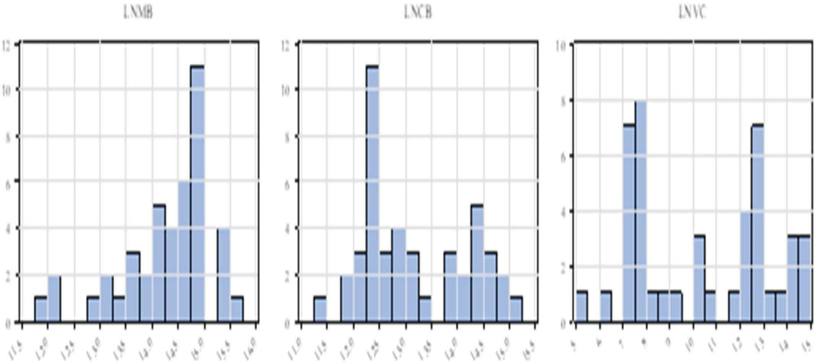

Figure 1: Variable histogram graphs.

LNMB LNCB LNVC

16

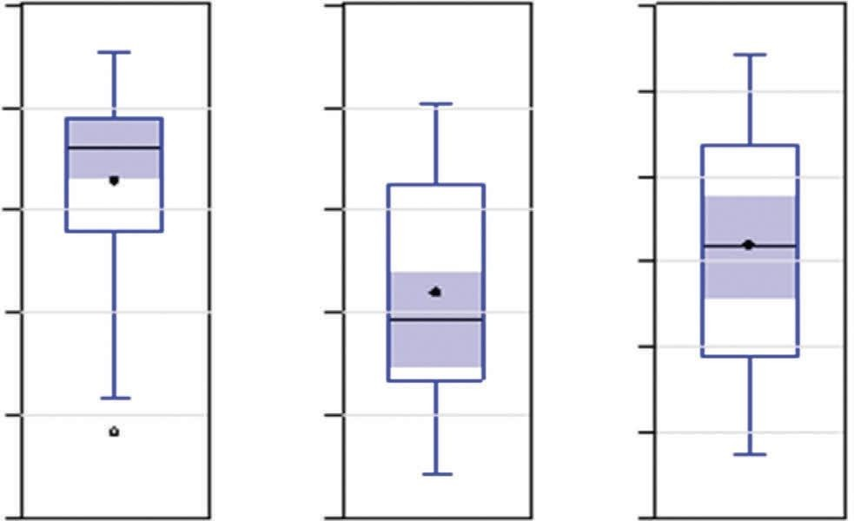

16

15

14

16

14

12

10

13

8

12

11

6

4

15

14

13

12

11

Figure 2: Variable box-plot plots.

aligns with the literature, which suggests that there is re- luctance towards image-based A.I. applications due to concerns such as privacy, surveillance, facial recognition, fake photo and video production, personality analysis, and cyber-attacks. The horizontal trend during 2015–2018 and

3637, 2024, 1, Downloaded from https://onlinelibrary.wiley.com/doi/10.1155/2024/9921363 by Lovely Professional University, Wiley Online Library on [09/09/2024]. See the Terms and Conditions (https://onlinelibrary.wiley.com/terms-and-conditions) on Wiley Online Library for rules of use; OA articles are governed by the applicable Creative Commons License

the upward trend after 2018 indicate that bank customers’ trust in image-processing A.I. applications differs and takes longer to develop than voice A.I. applications. In other words, customers are less inclined towards image-processing

A.I. applications. Therefore, it is recommended that sector

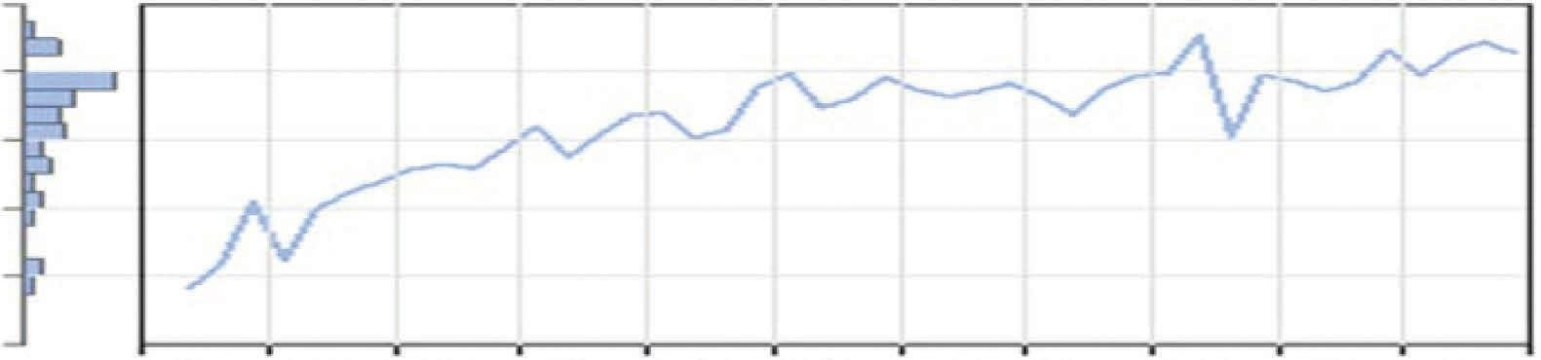LNMB

|  |  |
| --- | --- |
| 10 |  |
|  | 16 |
|  | 15 |
|  | 14 |
|  | 13 |
|  | 12 |
|  | 11 |
|  | 16 |
|  | 15 |
|  | 14 |
|  | 13 |
|  | 12 |
|  | 11 |
|  | 16 |
|  | 14 |
|  | 12 |
|  | 10 |
|  | 8 |
|  | 6 |
|  | 4 |

Advances in Human-Computer Interaction

|  |  |  |  |  |  |  |  |  |  |  |
| --- | --- | --- | --- | --- | --- | --- | --- | --- | --- | --- |
| 2012 | 2013 | 2014 | 2015 | 2016 | 2017 | 2018 | 2019 | 2020 | 2021 | 2022 |
|  |  |  |  |  | LNCB |  |  |  |  |  |
| 2012 | 2013 | 2014 | 2015 | 2016 | 2017  LNVC | 2018 | 2019 | 2020 | 2021 | 2022 |

|  |  |  |  |  |  |  |  |  |  |  |
| --- | --- | --- | --- | --- | --- | --- | --- | --- | --- | --- |
| 2012 | 2013 | 2014 | 2015 | 2016 | 2017 | 2018 | 2019 | 2020 | 2021 | 2022 |

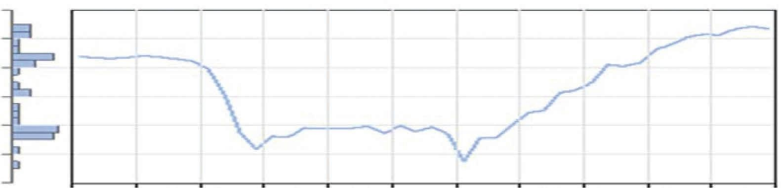Figure 3: Variable time path graphs.

Table 4: ADF and P.P. Unit root test results.

|  |  |  |  |
| --- | --- | --- | --- |
| Variable ADF  Fixed | Constant and trend | Fixed | PP  Constant and trend |
| LNMB −3.361(3)∗∗ | −4.451(0)∗∗∗ | −3.061{2}∗∗ | −4.401{3}∗∗∗ |
| [0.019] | [0.005] | [0.037] | [0.006] |
| LNCB −0.278(0) | −2.467(0)∗∗∗ | −0.076{3} | −2.445{2} |
| [0.919] | [0.342] | [0.946] | [0.353] |
| ∆ LNCB −5.715(1)∗∗∗ | −5.692(1)∗∗∗ | −7.329{0}∗∗∗ | −7.196{0}∗∗∗ |
| [≤0.001] | [≤0.001] | [≤0.001] | [≤0.001] |
| LNVC −0.463(0) | −1.064(0) | −0.906 {4} | −1.164 {2} |
| [0.889] | [0.923] | [0.777] | [0.905] |
| ∆ LNVC −4.811(0)∗∗∗ | −5.295(0)∗∗∗ | −4.911{3}∗∗∗ | −5.302{2}∗∗∗ |
| [≤0.001] | [≤0.001] | [≤0.001] | [≤0.001] |

∗∗∗denotes significance at (1%), ∗∗denotes significance at (5%), and ∗denotes significance at (10%) level. The null hypothesis for unit root tests is H0: the series contains a unit root. In other words, this means that the series is not stationary. ∆ denotes the first cyclical difference of the variable, [values in square brackets include the test significance value], (values in brackets include the optimal lag values and are determined in accordance with the Schwarz information criterion among lags up to a maximum of 12 lags. {The values in brackets contain the optimal bandwidth for the P.P. test and are determined in accordance with the Newey–West criterion}. The (+) on the decomposed variables denotes the positive shock variable, and the (−) denotes the negative shock variable.

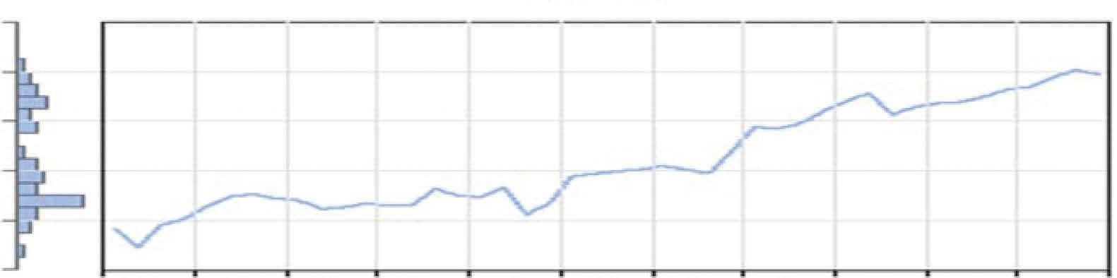managers design image-processing A.I. applications as se- cure systems within an ethical framework and include customers’ sensitivities regarding these issues in the pre- implementation processes to prevent resource wastage and contribute to gaining customer satisfaction and trust. The rejection of A.I. applications in the banking sector due to these negativities will also negatively affect technological diffusion. The findings of ADF and P.P. unit root tests applied to the variables are presented in Table 4.

3637, 2024, 1, Downloaded from https://onlinelibrary.wiley.com/doi/10.1155/2024/9921363 by Lovely Professional University, Wiley Online Library on [09/09/2024]. See the Terms and Conditions (https://onlinelibrary.wiley.com/terms-and-conditions) on Wiley Online Library for rules of use; OA articles are governed by the applicable Creative Commons License

Table 4 is analyzed, and it is seen that the null hypotheses expressing nonstationarity are rejected at least at a 5% significance level in line with the test statistics obtained from ADF and P.P. unit root tests with constant and D.F. models

with constant and trend for the LNMB variable (*p* < 0*.*045). The variable is a level stationary variable (LNMB∼I(0)).

The ADF and P.P. unit root tests for LNCB and LNVC

variables are analyzed, and it is found that the non- stationarity hypotheses cannot be rejected at 10%

Advances in Human-Computer Interaction 11

Table 5: Zivot–Andrews unit root test results.

|  |  |  |
| --- | --- | --- |
| Variable Fixed | Zivot-Andrews  Trend | Constant and trend |
| LNMB −4.196(3)∗∗ | −3.193(3)∗∗ | −3.673(3)∗∗∗ |
| [0.014] | [0.042] | [0.001] |
| LNCB −4.303(0)∗∗∗ | −3.629∗(0) | −4.262(0)∗∗∗ |
| [0.001] | [0.066] | [≤0.001] |
| LNVC −4.102(0)∗∗∗ | −3.452(0)∗∗∗ | −4.338∗(0) |
| [0.008] | [0.009] | [0.054] |

∗∗∗denotes significance at (1%), ∗∗denotes significance at (5%), ∗denotes significance at (10%) level. H for unit root tests 0: the series contains a unit root. (The series is not stationary). [Values in brackets contain the test significance value]; (values in brackets contain the optimal lag values and are determined by the Schwarz information criterion among 14 lags up to a maximum of 4 lags. (+) on the decomposed variables denotes the positive shock variable, and (−) denotes the negative shock variable.

LNCB

LNMB

|  |  |  |  |  |  |  |
| --- | --- | --- | --- | --- | --- | --- |
| 16 |  | | | | | |
| 15 |  |  |  |  |  |  |
| 14 |  |  |  |  |  |  |
| 13 |  |  |  |  |  |  |
| 12 |  |  |  |  |  |  |
| 11 |  |  |  |  |  |  |
| 16 |  |  |  |  |  |  |
| 15 |  |  |  |  |  |  |
| 14 |  |  |  |  |  |  |
| 13 |  |  |  |  |  |  |
| 12 |  |  |  |  |  |  |
| 11 |  |  |  |  |  |  |
| 16 |  |  |  |  |  |  |
| 14 |  |  |  |  |  |  |
| 12 |  |  |  |  |  |  |
| 10 |  |  |  |  |  |  |
| 8 |  |  |  |  |  |  |
| 6 |  |  |  |  |  |  |
| 4 |  |  |  |  |  |  |
|  | 11 12 13 14 15 16 11 12 13 14 15 16  LNMB LNCB | 4 | 8 | LNVC | 12 | 16 |

Figure 4: Scatter matrix and correlation coefficients between variables.

LNVC

significance levels (*p* > 0*.*10). However, when the ADF and

3637, 2024, 1, Downloaded from https://onlinelibrary.wiley.com/doi/10.1155/2024/9921363 by Lovely Professional University, Wiley Online Library on [09/09/2024]. See the Terms and Conditions (https://onlinelibrary.wiley.com/terms-and-conditions) on Wiley Online Library for rules of use; OA articles are governed by the applicable Creative Commons License

P.P. unit root tests for the first difference variables are

analyzed, it is seen that the nonstationarity hypotheses are rejected at a 1% significance level (*p* < 0*.*01) in line with the test statistics of the models with constant and with constant and trend calculated at level values. In other words, it is seen

that these variables are nonstationary at level but become stationary after taking the first cyclical difference (LNCB, LNVC∼I(1)).

Although it is known that only the LNVC variable has

structural break characteristics, Zivot–Andrews unit root tests with structural break were applied for all variables. In case of inconsistency between ADF and P.P. tests and Zivot–Andrews test, ADF and P.P. unit root tests will be considered for LNMB and LNCB variables that do not exhibit structural breaks, and Zivot–Andrews unit root tests

will be considered for LNVC that exhibits structural breaks. Zivot–Andrews unit root test findings are as in Table 5.

Table 5 is analyzed, and it is seen that the null hypotheses suggesting that the variables are nonstationary are rejected at least at a 10% significance level (*p* < 0*.*10) in line with the test statistics calculated over the Zivot–Andrews test unit root models with constant break, trend break, and both trend and

constant break for all variables. In this case, in line with the Zivot–Andrews unit root test findings with structural breaks, the variables are stationary at the level. As explained above, LNMB and LNCB variables are not variables with structural break characteristics. For this reason, the ADF and P.P. unit root tests for the LNMB and LNCB variables were con- ducted, and it was determined that LNMB is a level sta- tionary variable. At the same time, LNCB is a nonstationary variable in level but stationary in the first cyclical difference.

12 Advances in Human-Computer Interaction

-4.2

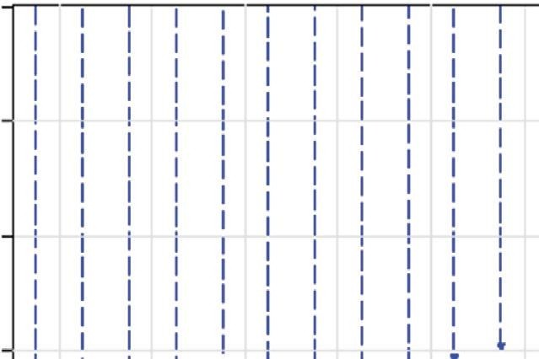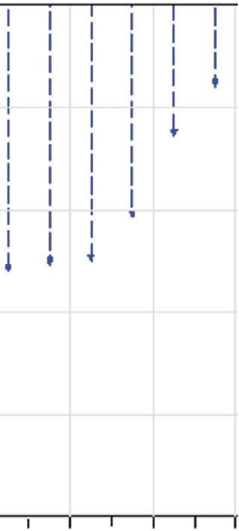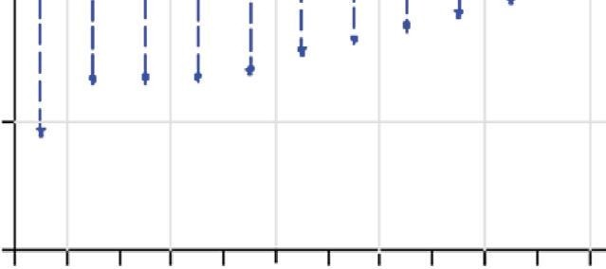

-4.3

-4.4

-4.5

-4.6

-4.7

-4.24

-4.28

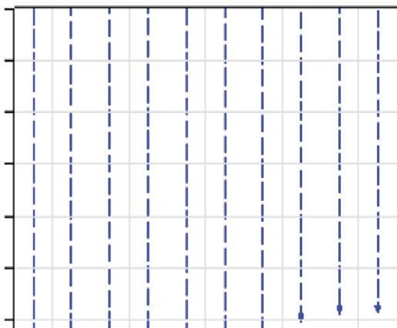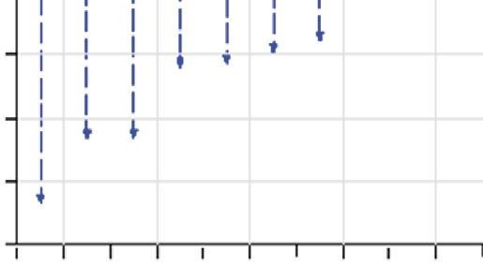

-4.32

-4.36

-4.40

-4.44

-4.48

-4.52

-4.56

-4.60

-4.64

ARDL (3, 0)

ARDL (4, 0)

ARDL (3, 3)

ARDL (3, 2)

ARDL (3, 1)

ARDL (4, 3)

ARDL (4, 2)

ARDL (4, 1)

ARDL (3, 4)

ARDL (2, 0)

ARDL (4, 4)

ARDL (2, 1)

ARDL (2, 3)

ARDL (2, 2)

ARDL (2, 4)

ARDL (1, 0)

ARDL (1, 2)

ARDL (3, 0)

ARDL (3, 1)

ARDL (4, 0)

ARDL (4, 1)

ARDL (3, 2)

ARDL (3, 3)

ARDL (2, 0)

ARDL (4, 2)

ARDL (2, 1)

ARDL (4, 3)

ARDL (3, 4)

ARDL (2, 3)

ARDL (2, 2)

ARDL (4, 4)

ARDL (2, 4)

ARDL (1, 0)

ARDL (1, 1)

(a) (b)

Figure 5: Akaike information criterion comparisons for optimal lags. (a) Model 1. (b) Model 2.

Table 6: ARDL model results.

Panel A: F border test results H0: there is no cointegration

Model 1: ARDL (3, 0) Model 2: ARDL (3, 0)

*F* � 34.010∗∗∗ *k* � 1 *F* � 34.1001∗∗∗ *k* � 1

Significance I (0) I (1) I (0) I (1)

%1 5.593 6.333 5.593 6.333

%5 3.937 4.523 3.937 4.523

%10 3.210 3.730 3.210 3.730

Panel B: long run statistics

Variable

Model 1: ARDL (3, 0) Model 2: ARDL (3, 0)

*β* S.H. *T p β* S.H. *t p*

LNCB 0.201 0.057 3.524∗∗∗ [0.001] —

LNVC — 0.041 0.014 2.981∗∗∗ [0.005]

Fixed term 15.869 0.837 18.948∗∗∗ [≤0.001] 18.363 0.174 105.832∗∗∗ [≤0.001]

Panel C: error correction model and short run statistics

Variable

Model 1: ARDL (3, 0) Model 2: ARDL (3, 0)

*β* S.H. *t p β* S.H. *t p*

ECM*t*−1 −0.129 0.012 −10.378∗∗∗ [≤0.001] −0.115 0.011 −10.392∗∗∗ [0.001]

LNMB*t*−1 −0.129 0.014 −9.436∗∗∗ [≤0.001] −0.115 0.012 −9.880∗∗∗ [≤0.001]

∆LNMB*t*−1 −0.567 0.121 −4.692∗∗∗ [≤0.001] −0.574 0.121 −4.735∗∗∗ [≤0.001]

∆LNMB*t*−2 −0.450 0.118 −3.814∗∗∗ [≤0.001] −0.450 0.118 −3.818∗∗∗ [0.001]

∆LNCB*t* 0.026 0.009 2.870∗∗∗ [0.007] —

∆LNVCt — 0.005 0.002 2.885∗∗∗ [0.007]

Fixed term 2.047 0.211 9.688∗∗∗ [≤0.001] 2.104 0.213 9.871∗∗∗ [≤0.001]

Panel D: diagnostic statistics

Model 1: ARDL (3, 0) Model 2: ARDL (3, 0)

LM autocorrelation test *χ*2 (02) � 4.011 [0.134] *χ*2 (02) � 3.807 [0.149]

White heteroskedasticity test *χ*2 (04) �

19.069∗∗∗

[≤0.001] χ2(04) � 16.854∗∗∗ [0.002]

Ramsey reset *F*(1, 35) � 2.561 [0.119] *F*(1, 35) � 2.415 [0.129]

3637, 2024, 1, Downloaded from https://onlinelibrary.wiley.com/doi/10.1155/2024/9921363 by Lovely Professional University, Wiley Online Library on [09/09/2024]. See the Terms and Conditions (https://onlinelibrary.wiley.com/terms-and-conditions) on Wiley Online Library for rules of use; OA articles are governed by the applicable Creative Commons License

Error terms *ε*∼*N*(0, *σ*2) *ε*∼*N*(0, *σ*2)

∗∗∗denotes significance at (1%), ∗∗denotes significance at (5%), and ∗denotes significance at (10%) level. [Brackets contain test significance values]. ∆: indicates the first cyclical difference of the variable, χ2: chi-square test statistic, F: F-test statistic, (inside brackets include test degrees of freedom).

Advances in Human-Computer Interaction 13

Autocorrelation Partial Correlation AC PAC Q-Stat Prob*

1.2267 0.268

1.2347 0.539

3.7498 0.290

3.9626 0.411

4.0756 0.539

5.0229 0.541

5.5043 0.599

5.6165 0.690

5.6166 0.778

7.4898 0.679

8.0524 0.709

8.0989 0.777

8.7975 0.788

10.330 0.738

14.141 0.515

15.388 0.496

16.126 0.515

16.795 0.537

17.081 0.584

17.429 0.625

1 0.167

2 0.013

3 -0.233

4 0.067

5 -0.048

6 -0.137

7 -0.096

8 -0.046

10 -0.181

11 -0.098

12 0.028

13 0.105

14 -0.153

15 -0.237

16 -0.133

17 0.100

18 0.093

19 0.060

20 0.064

9 0.001

0.167

-0.015

-0.239

0.158

-0.089

-0.198

0.033

-0.074

-0.063

-0.180

-0.078

0.043

-0.034

-0.249

-0.219

-0.155

-0.055

-0.077

-0.064

-0.062

Figure 6: Model 1 correlogram graph.

9

Seri: Hata Terimleri Örneklem: 2012Q1-2022Q4 Gözlem Sayısı:41 Ortalama=1.53e-15 Maksimum=0.085440 Minimum=-0.055327 Standart Sapm a=0.027259 Çarpıklık (S)=0.670804 Basıklık (K)=4.106774 Jarque Berra=5.167468 p=0.075492

8

7

6

5

4

3

2

1

0

-0.06 -0.04 -0.02 -0.00 0.02 0.04 0.06 0.08

Figure 7: Summary of model 1 error terms.

3637, 2024, 1, Downloaded from https://onlinelibrary.wiley.com/doi/10.1155/2024/9921363 by Lovely Professional University, Wiley Online Library on [09/09/2024]. See the Terms and Conditions (https://onlinelibrary.wiley.com/terms-and-conditions) on Wiley Online Library for rules of use; OA articles are governed by the applicable Creative Commons License

For the LNVC variable, which shows a structural break feature, it is decided that it is a level stationary variable in line with the Zivot–Andrews unit root test (LNMB∼I(0),

LNCB∼I(0), LNVC∼I(0)). The scatter plots and correlation

coefficients between the variables are presented in Figure 4.

When the divergence graphs between the variables are examined (Figure 4), it is seen that there is a close correlation relationship between the dependent variable LNMB and the independent variable LNCB in the first model. In parallel with the visual finding, the correlation coefficient was cal- culated as statistically significant positive and above medium

size (RXY � 0.773, *p* < 0*.*01) at a 1% significance level.

In the second model, there is no visual evidence of

a correlational relationship between the dependent variable LNMB and the independent variable LNVC, and the cor- relation coefficient is statistically insignificant at the 10% significance level (RXY � −0.31, *p* > 0*.*10).

There is a visually detectable moderate correlational relationship between LNCB and LNVC, included as in- dependent variables in two different models, and a moderate positive correlation at a 1% significance level (RXY � 0.508, *p* < 0*.*01).

Since the variables in the research models are stationary

variables of different orders, none of the variables are sta- tionary of the second order, and it is known that small sample characteristics are reasonable, and it was decided to estimate the models using ARDL cointegration methods.

Figure 5 presents Akaike Information Criterion com- parisons to determine the optimal lags in the autoregressive lagged equations for the ARDL model.

Figure 5(a) shows that the best (smallest) Akaike In- formation Criterion is calculated for the ARDL (3, 0) model. In other words, the ARDL model with three lags of the dependent variable LNMB and unlagged values of the

14 Advances in Human-Computer Interaction

Autocorrelation Partial Correlation AC PAC Q-Stat Prob*

1 0.144 0.144 0.9189

2 -0.030 -0.052 0.9592

3 -0.270 -0.265 4.3532

4 0.029 0.114 4.3921

5 -0.104 -0.152 4.9190

6 -0.216 -0.280 7.2658

7 -0.106 0.007 7.8433

8 0.047 -0.023 7.9588

9 0.110 -0.041 8.6286

10 -0.103 -0.155 9.2324

11 -0.007 -0.001 9.2350

12 0.128 0.100 10.239

13 0.125 -0.037 11.227

14 -0.179 -0.214 13.330

15 -0.319 -0.258 20.212

16 -0.179 -0.214 22.484

17 0.059 -0.082 22.741

18 0.048 -0.129 22.920

19 0.064 -0.063 23.250

20 0.083 -0.122 23.825

0.338

0.619

0.226

0.356

0.426

0.297

0.347

0.438

0.472

0.510

0.600

0.595

0.592

0.501

0.164

0.128

0.158

0.194

0.227

0.250

Figure 8: Model 2 correlogram graph.

9

Seri: Hata Terimleri Örneklem: 2012Q1-2022Q4 Gözlem Sayısı:41 Ortalama=1.78e-15 Maksimum=0.084807 Minimum=-0.053971 Standart Sapm a=0.027233 Çarpıklık (S)=0.682391 Basıklık (K)=4.172465 Jarque Berra=5.530399 p=0.062964

8

7

6

5

4

3

2

1

0

-0.06 -0.04 -0.02 -0.00 0.02 0.04 0.06 0.08

Figure 9: Summary of model 2 error terms.

independent variable LNCB is optimal. Similarly, Figure 5(b) shows that the best (Smallest) Akaike Information Criterion is calculated for the ARDL (3, 0) model. In this framework, the ARDL model with three lags of the dependent variable LNMB and unlagged values of the independent variable LNVC is more optimal. The model findings, including the F- bounds test, long-run statistics, error correction model short-run statistics, and diagnostic tests obtained from ARDL models with optimal lags, are presented in Table 6. The diagnostic tests for model 1 in Table 5 are analyzed, and it is seen that there is no statistically significant auto- correlation problem in the model at a 10% significance level

3637, 2024, 1, Downloaded from https://onlinelibrary.wiley.com/doi/10.1155/2024/9921363 by Lovely Professional University, Wiley Online Library on [09/09/2024]. See the Terms and Conditions (https://onlinelibrary.wiley.com/terms-and-conditions) on Wiley Online Library for rules of use; OA articles are governed by the applicable Creative Commons License

(*χ*2 (02) � 4.011, *p* > 0*.*10), but there is a significant changing variance problem at 1% significance level (*χ*2 (04) � 19.069, *p* < 0*.*01). In order to prevent efficiency losses that may arise from the problem of changing variance, the model is

estimated to have robust HAC-NEWEY-WEST standard errors. No functional form error was observed in the model, and the error terms were found to be in a clean series. The correlogram graph and summary of error terms for the model up to 20 lags are presented in the appendices (Figures 6 and 7). When the F statistic for the cointegration hypothesis test for model 1 is examined, it is seen that it is well above the critical values for the 1% significance level

(*F* � 34.010 > 6.333). In this case, the null hypothesis of no cointegration is rejected, and there is a statistically signifi-

cant cointegration relationship between the variables at the 1% significance level.

The long-run findings are analyzed, and it is observed that the coefficient calculated for LNCB is statistically sig- nificant and positive at a 1% significance level (*β* � 0.201, *p* < 0*.*01). In other words, a 1% increase/decrease in Chat

Advances in Human-Computer Interaction 15

20

|  |  |  |  |  |  |  |  |  |
| --- | --- | --- | --- | --- | --- | --- | --- | --- |
| 20 |  |  |  |  |  |  | 1.4 |  |
| 15 |  |  |  |  |  |  | 1.2 |
| 10 |  |  |  |  |  |  | 1.0 |
| 5 |  |  |  |  |  |  | 0.8 |
| 0 |  |  |  |  |  |  | 0.6 |
|  |  |  |  |  |  |  | 0.4 |
| -5 |  |  |  |  |  |  | 0.2 |
| -10 |  |  |  |  |  |  | 0.0 |
| -15 |  |  |  |  |  |  | -0.2 |
| -20 | 2014 2015 2016 | 2017 | 2018 | 2019 | 2020 | 2021 | -0.4 | 2014 2015 2016 2017 2018 2019 2020 2021 |
|  | CUSUM  %5 Anlamlilik |  |  |  |  |  |  | CUSUM Kare  %5 Anlamlilik |

15

10

5

0

-5

-10

-15

-20

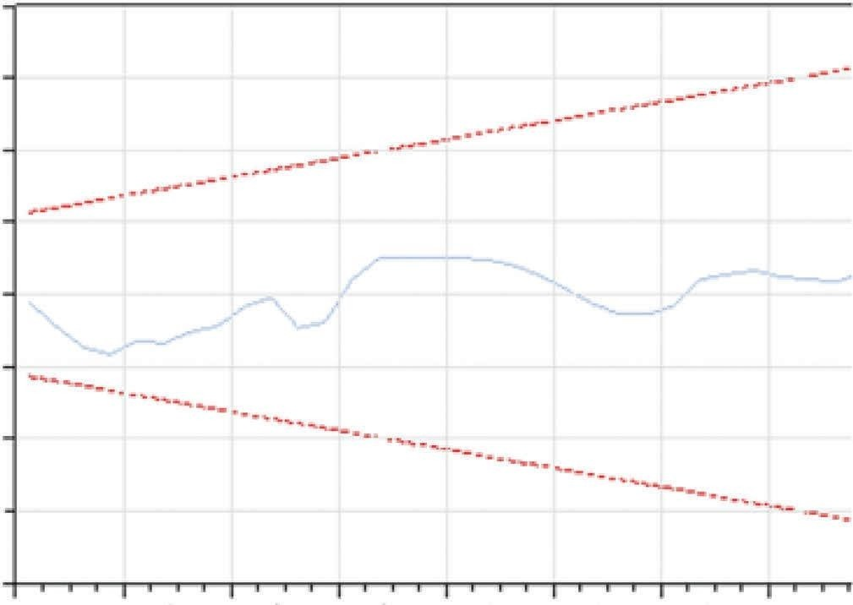

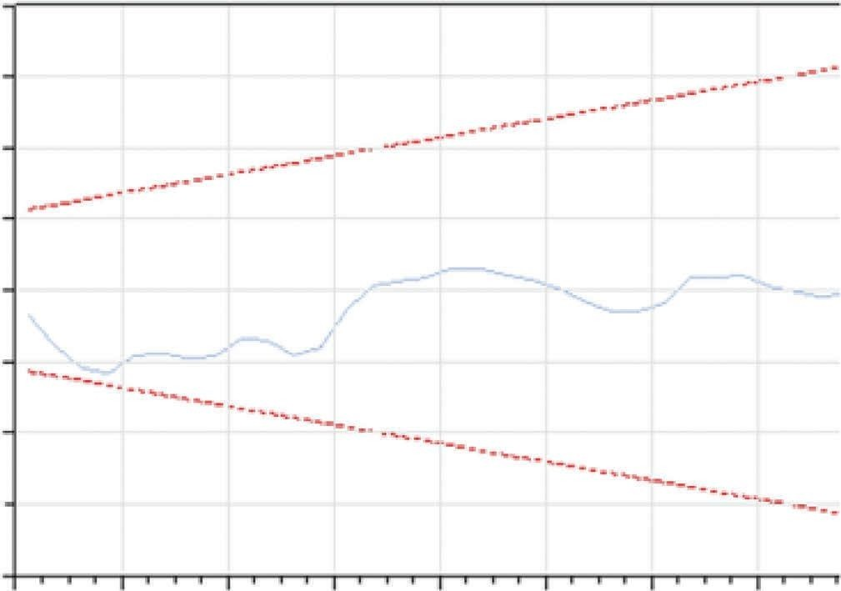

2014 2015 2016 2017 2018 2019 2020 2021

CUSUM

%5 Anlamlilik

(a)

1.4

1.2

1.0

0.8

0.6

0.4

0.2

0.0

-0.2

-0.4

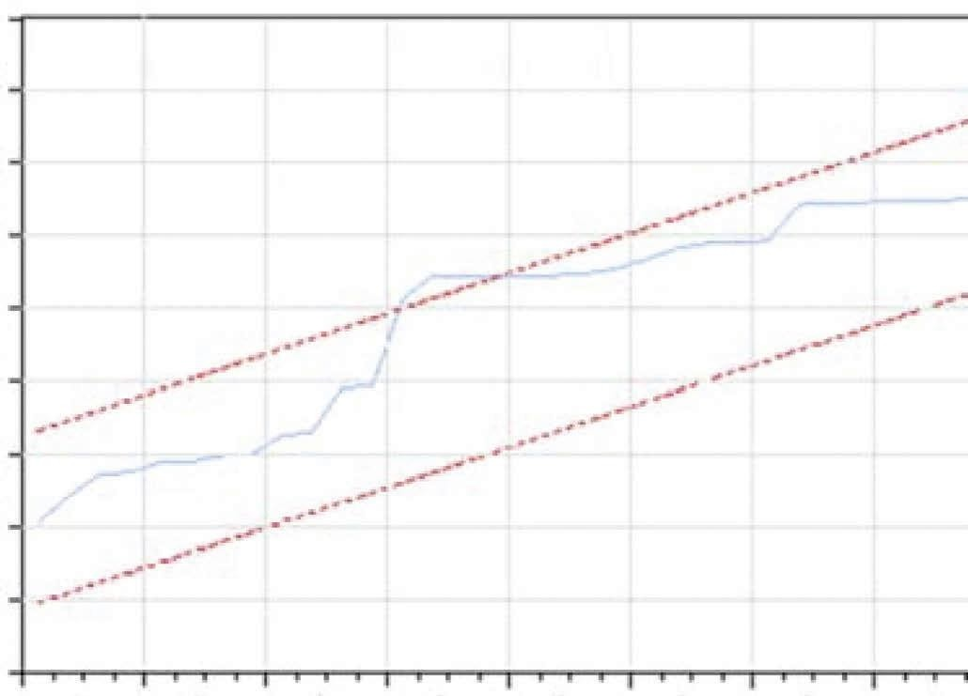

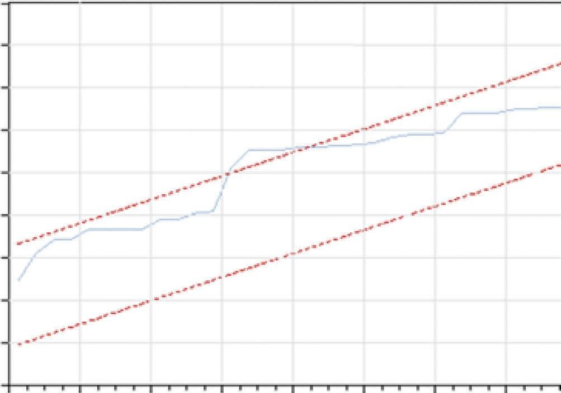

2014 2015 2016 2017 2018 2019 2020 2021

CUSUM Kare

%5 Anlamlilik

(b)

Figure 10: Coefficient stability tests. (a) Mode 1 stability tests. (b) Mode 1 stability tests.

Box applications in the long run causes an increase/decrease of approximately 0.2% in mobile banking applications.

3637, 2024, 1, Downloaded from https://onlinelibrary.wiley.com/doi/10.1155/2024/9921363 by Lovely Professional University, Wiley Online Library on [09/09/2024]. See the Terms and Conditions (https://onlinelibrary.wiley.com/terms-and-conditions) on Wiley Online Library for rules of use; OA articles are governed by the applicable Creative Commons License

The error correction mechanism is analyzed in the context of equilibrium adjustment of deviations from long- run equilibrium; it is observed that the error correction term is statistically significant at a negative 1% significance level and smaller than 1 in absolute value 17 as expected (ECMt-

1 � −0.129, *p* < 0*.*01). In this case, the error terms periodi- cally rebalance long-run deviations throughout the periods.

When the adjustment coefficient is analyzed, the equilibrium deviations are rebalanced in approximately eight periods (2 years) (1/0.129 � 7.75).

The short-term coefficients are analyzed, and it is seen that the short-term coefficient of the LNCB variable on the LNMB variable is statistically significant and positive (*β* � 0.026, *p* < 0*.*01) at a 1% significance level. This result means that a 1% increase/decrease in the number of Chat

Boxes in the current period increases/decreases mobile banking applications by approximately 0.03% in the current period.

The diagnostic tests for model 2 in Table 6 are analyzed. It is seen that there is no statistically significant autocor- relation problem in the model at a 10% significance level (*χ*2 (0*.*2) � 3*.*807, *p* > 0*.*10). However, there is a significant changing variance problem at a 1% significance level (*χ*2 (04) � 16*.*854, *p* < 0*.*01). In order to avoid efficiency losses that may arise from the varying variance problem, the model is estimated with HAC-NEWEY-WEST robust

standard errors. No functional form error was observed in the model, and the error terms were found to be in a clean series. The correlogram graph and summary of error terms for the model up to 20 lags are presented in the appendices (Figures 8 and 9).

The F statistic for the cointegration hypothesis test for model 2 is examined, and it is seen that it is well above the critical values for the 1% significance level (*F* � 34.101 > 6.333). In this case, it is determined that the null hypothesis of no cointegration is rejected and there is

a statistically significant cointegration relationship between the variables at the 1% significance level.

16 Advances in Human-Computer Interaction

The long-run findings are analyzed, and it is observed that the coefficient calculated for LNVC is statistically sig- nificant and positive at a 1% significance level (*β* � 0.041, *p* < 0*.*01). More precisely, a 1% increase/decrease in video call applications in the long run causes an increase/decrease

3637, 2024, 1, Downloaded from https://onlinelibrary.wiley.com/doi/10.1155/2024/9921363 by Lovely Professional University, Wiley Online Library on [09/09/2024]. See the Terms and Conditions (https://onlinelibrary.wiley.com/terms-and-conditions) on Wiley Online Library for rules of use; OA articles are governed by the applicable Creative Commons License

of approximately 0.04% in mobile banking applications.

The error correction mechanism is analyzed in the context of equilibrium adjustment of deviations from long- run equilibrium; it is seen that the error correction term is statistically significant at a negative 1% significance level and smaller than 1 in absolute value as expected (ECMt-

1 � −0.115, *p* < 0*.*01). In this case, the error terms periodi- cally rebalance long-run deviations throughout the periods.

When the adjustment coefficient is analyzed, the equilibrium deviations are rebalanced in approximately nine periods (9 quarters) (1/0.129 � 8.69).

The short-term coefficients are analyzed, and it is seen that the short-term coefficient of the LNCV variable on the LNMB variable is statistically significant and positive at a 1% significance level (*β* � 0.005; *p* < 0*.*01). More precisely, a 1% increase/decrease in the number of video calls in the current

period increases/decreases mobile banking applications by approximately 0.005% in the current period.

The stability conditions of the estimated coefficients for the models were examined using the Cusum and Cusum square tests. The Cusum and Cusum square test graphs are presented in Figure 10. The Cusum and Cusum squared test statistics for model 1 are analyzed, and it is seen that it is within the 5% significance band for all periods. In other words, the stability condition for model 1 is met at a 5% significance level. The Cusum and Cusum squared test sta- tistics for model 2 are analyzed. It is seen that the Cusum test statistic is within the 5% significance band throughout all periods, while the Cusum squared test statistic is outside the 5% significance band for a short period, but these values do not approach the 10% significance level. In this case, according to the findings of the Cusum test for model 2, the stability condition is met at a 5% significance level and, according to the Cusum squared test, at a 10% significance level.

The model results reveal that the number of mobile

banking users and customers using the chat box and video call

A.I. applications move together in the long and short terms. Both AI applications contribute positively to the number of mobile banking users, providing strong evidence that the sector can use them to promote digital banking. However, as seen above, the impact of video call and chat box variables on digital banking could be more substantial in the short term compared to the long term. The effect of the video call A.I. application is weaker in the long and short terms compared to the chat box application that provides service without video. These results are consistent with the downward trend ob- served in the video call time series graph (Figure 3) during 2012–2015 and the horizontal trend during 2015–2018.

# Conclusions

The present study examined the effects of artificial in- telligence applications in the banking sector in Turkey on Turkish digital banking and the long and short-term

relationship using the econometric analysis method. The cointegration and regression equation analyses (1) and (2) were performed using the ARDL bounds’ test approach in two stages. According to the F statistic results of the first stage cointegration hypothesis test, a statistically significant relationship exists between the variables at a 1% significance level. The results confirm the existence of long-term and short-term cointegration between the independent variables and the dependent variable digital banking and show that the variables representing the number of digital banking and artificial intelligence applications move together in the long term. In the second stage, regression equations (1) and (2) were analyzed to explain the dilemma discussed in the in- troduction about how individuals’ participation in A.I. applications affects digital banking. According to the ARDL regression model test results, a 1% increase in the number of users of chat box applications leads to a 0.2% increase in the number of users of mobile banking applications in the long term. However, this effect weakens in the short term, as a 1% increase leads to an increase of approximately 0.03%. A 1% increase in video call applications in the long term leads to an increase of approximately 0.04% in mobile banking applications, and a 1% increase in the short term leads to an increase of about 0.005%. The results show that both A.I. applications positively impact the number of mobile banking users. The results provide strong evidence that the artificial intelligence application of chat boxes and video calls can be utilized in the sector to expand digital banking. The study results also support the results of the study by Gumus et al.

1. that the effective use of artificial intelligence in the fi-

nancial sector provides excellent convenience for users and the results of Dogan [73] that the output quality, perceived ease of use, and perceived usefulness structures of artificial intelligence applications have the highest impact on mobile banking usage.

However, the impact of video call and chat box variables on digital banking could be more substantial in the short term than in the long term. The results could also indicate that artificial intelligence applications are only sometimes adopted in the short term. Diffusion of innovation theories also suggests that the diffusion of innovations will be weak in the short term, consistent with the theoretical framework. It is also noteworthy that the video call A.I. application has a weaker effect in the long and short terms compared to the chat box application that offers video-free service. The study supports the literature (Eltimur, [11]; Turan et al., [12]; Oztemel, [10, 51]) discussed in the theoretical section that some individuals do not favor artificial intelligence appli- cations for image-based and one-to-one personal applica- tions for reasons such as privacy, surveillance, face recognition, fake photo and video production, personality analysis, cyber-attack, and information theft. As discussed in the literature, this result is in line with the theoretical framework of the diffusion of innovations theory [50], which states that individuals may display behaviors of rejecting and adopting some innovations.

The study provides the following policy recommenda-

tions, considering the positive impact of artificial in- telligence applications (chat box and video call) on digital

Advances in Human-Computer Interaction 17

banking. Within the framework of technological diffusion theories, sector managers are advised to use the chat box application as a variable in their policy to increase the number of mobile banking users. Thus, they could enable the spread of digital banking technology to the broader part of society. As mentioned in the introduction, the number of call center employees in the banking sector in Turkey constitutes approximately 5.4% of the total number of employees. By expanding the chat box and video call arti- ficial intelligence applications, call centers could save on the number of personnel working in call centers, thus reducing their costs and increasing their profitability. However, in- dustry executives are also advised to keep in mind that the impact of video calling A.I. on digital banking is relatively low. This is because image-processing artificial intelligence applications contribute little to the spread of digital banking. According to the diffusion of innovation theory, some in- novations are likely to be rejected by society and individuals. The study reveals the positive impact of the chat box and video call artificial intelligence applications on digital banking in the Turkish banking sector. It also provides strong empirical evidence to explain whether to emphasize voice or video technologies from A.I. applications for the expansion of digital banking. It provides policy recom- mendations regarding the more effective use of chat box artificial intelligence applications as a means of digital banking dissemination, while the impact of image pro- cessing artificial intelligence applications is shallow. Besides these strengths, the study can contribute to similar studies to be conducted in the future, which are suggested below. Conducting comparative analyses on data from developed and emerging economies with different models and A.I. variables can provide significant insights into individuals’ behaviors and attitudes towards A.I. applications in the banking sector. Cross-cultural and transnational studies can be conducted to identify how specific social and cultural characteristics among members of a society influence the adoption of technologies and services. A comparative analysis of mobile banking adoption by stakeholders in rural and urban areas can be examined from a different per- spective. Such studies could help microfinance institutions better understand consumers’ preferences and choices and improve their future marketing plans by building a mobile

banking culture, especially in emerging economies.

In the future, other researchers can investigate how and in what direction chat box and video call A.I. applications affect traditional banking. They can select the population per branch or the number of bank staff as dependent variables in traditional banking. If data on transaction volumes and the number of transactions conducted through branches using traditional methods are obtained, more accurate and ex-

citing results can be presented. They can perform panel time

and works under the assumption of slope homogeneity, can be used. This estimator can include the unique structures of countries in the model. The long-term relationship and the effects of A.I. applications on traditional and mobile banking in groups of Developing Countries, Developed Countries (G-7), Fragile Five Countries, and OECD countries can be examined. The findings will be significant in revealing how much the use of A.I. applications affects traditional banking. In this way, findings can be obtained on the extent and speed at which banks abandon traditional banking practices. This can guide the necessity of adapting A.I. applications to the functioning of banks. A review of the literature indicates that there are no such studies to guide banks [74,](#_bookmark84) [75].

# Data Availability

Data open access address is [https://www.tbb.org.tr/tr/](https://www.tbb.org.tr/tr/bankacilik/banka-ve-sektor-bilgileri/istatistiki-raporlar/59) [bankacilik/banka-ve-sektor-bilgileri/istatistiki-raporlar/59.](https://www.tbb.org.tr/tr/bankacilik/banka-ve-sektor-bilgileri/istatistiki-raporlar/59)

# Conflicts of Interest

The authors declare that they have no conflicts of interest.

# References

1. C. Stoicescu, “Big data is the perfect instrument to study today’s consumer behavior,” *Database Systems Journal*, no. 3,

pp. 29–39, 2015.

1. A. T. Stephen, “Here comes the hyper-connected augmented consumer,” *GfK Marketing Intelligence Review*, vol. 9, no. 2,

pp. 10–17, 2017.

1. J. Sutanto, E. Palme, C. Tan, and C. W. Phang, “Addressing the personalization privacy paradox: an empirical assessment from a field experiment on smartphone users,” *MIS Quarterly*, vol. 37, no. 4, pp. 1141–1164, 2013.
2. M. Albashrawi and L. Motiwalla, “Privacy and personalization in continued usage intention of mobile banking: an in- tegrative perspective,” *Information Systems Frontiers*, vol. 21, no. 5, pp. 1031–1043, 2019.
3. A. Akbaba and C. Gu¨ndog˘du, “Use of artificial intelligence in banking services,” *Journal of Academic Value Studies*, vol. 7, no. 3, pp. 298–315, 2021.
4. O. Yıldırım, “Banking system development and banking system,” *Turkey International Journal of Financial Economics* *and Banking Practices*, vol. 2020, 77 pages, 2020.
5. Banks Association of Turkey (BAT), “Banks Association of Turkey (BAT) Reports,” 2024, [https://www.tbb.org.tr/tr/](https://www.tbb.org.tr/tr/bankacilik/banka-ve-sektor-bilgileri/istatistiki-raporlar/59) [bankacilik/banka-ve-sektor-bilgileri/istatistiki-raporlar/59.](https://www.tbb.org.tr/tr/bankacilik/banka-ve-sektor-bilgileri/istatistiki-raporlar/59)
6. Banks Association of Turkey, “Digital, Internet, and Mobile Banking Statistics Report, September 2023,” Report, 2023, [https://www.tbb.org.tr/Content/Upload/istatistikiraporlar/](https://www.tbb.org.tr/Content/Upload/istatistikiraporlar/ekler/4057/Dijital-Internet-Mobil_Bankacilik_Istatistikleri-Mart_2023.pdf) [ekler/4057/Dijital-Internet-Mobil_Bankacilik_Istatistikleri-](https://www.tbb.org.tr/Content/Upload/istatistikiraporlar/ekler/4057/Dijital-Internet-Mobil_Bankacilik_Istatistikleri-Mart_2023.pdf) [Mart_2023.pdf.](https://www.tbb.org.tr/Content/Upload/istatistikiraporlar/ekler/4057/Dijital-Internet-Mobil_Bankacilik_Istatistikleri-Mart_2023.pdf)
7. E. Gu¨mu¨¸s, B. Medetog˘lu, and S. Tutar, “Finans ve bankacılık

series analysis using data from similar groups of countries

sisteminde yapay zekaˆ kullanımı: kullanıcılar u¨zerine bir

concerning traditional banking. They can use econometric models and estimators considering interunit correlation and structural breaks in time series analysis. In this context, the second-generation panel regression estimator Common Correlated Effects (CCE), developed by Pesaran and Chudik [72], which accounts for the problem of interunit correlation

3637, 2024, 1, Downloaded from https://onlinelibrary.wiley.com/doi/10.1155/2024/9921363 by Lovely Professional University, Wiley Online Library on [09/09/2024]. See the Terms and Conditions (https://onlinelibrary.wiley.com/terms-and-conditions) on Wiley Online Library for rules of use; OA articles are governed by the applicable Creative Commons License

uygulama,” *Bucak ˙I¸sletme Faku¨ltesi Dergisi*, vol. 3, no. 1,

pp. 28–53, 2020.

1. E. O¨ ztemel, *Artificial Intelligence and the Future of Humanity*, 2020.
2. D. Y. Eltimur, “Artificial intelligence applications in the context of the protection of human rights,” *Journal of Akdeniz University Faculty of Law*, vol. 12, no. 2, pp. 559–594, 2022.

18 Advances in Human-Computer Interaction

1. T. Turan, G. Turan, and E. U. Ku¨çu¨ksille, “Ethics of artificial intelligence: impact on society,” *The Journal of Graduate School of Natural and Applied Sciences of Mehmet Akif Ersoy* *University*, vol. 13, no. 2, pp. 292–299, 2022.
2. S. Melek and H. Çetiner, *Deep Learning Applications in* *MATLAB Environment*, B. Iksad Publishing House, 2021.
3. K. Hil’ovska´ and P. Koncz, “Application of artificial in-
4. J. F. Nielsen, “Internet technology and customer linking in Nordic banking,” *Internal Journal of Service Banking*, vol. 13, no. 2, pp. 475–496, 2002.
5. D. L. Marafon, K. Basso, L. B. Espartel, M. D. de Barcellos, and

E. Rech, “Perceived risk and intention to use Internet banking,” *International Journal of Bank Marketing*, vol. 36, no. 2, pp. 277–289, 2018.

telligence and data mining techniques to financial markets,”

3637, 2024, 1, Downloaded from https://onlinelibrary.wiley.com/doi/10.1155/2024/9921363 by Lovely Professional University, Wiley Online Library on [09/09/2024]. See the Terms and Conditions (https://onlinelibrary.wiley.com/terms-and-conditions) on Wiley Online Library for rules of use; OA articles are governed by the applicable Creative Commons License

*Economic Studies & Analyses/Acta VSFS*, vol. 6, no. 1,

pp. 62–76, 2012.

1. J. P. Haton, “A brief introduction to artificial intelligence,”

*IFAC Proceedings Volumes*, vol. 39, no. 4, pp. 8–16, 2006.

1. S. Moro, P. Cortez, and P. Rita, “Business intelligence in banking: a literature analysis from 2002 to 2013 using text mining and latent Dirichlet allocation,” *Expert Systems with* *Applications*, vol. 42, no. 3, pp. 1314–1324, 2015.
2. R. Morgan, “The top fintech trends driving the next decade,”

*ABA Banking Journal*, no. 5, pp. 22–27, 2017.

1. P. Hanafizadeh, B. W. Keating, and H. R. Khedmatgozar, “A systematic review of Internet banking adoption,” *Telematics* *and Informatics*, vol. 31, no. 3, pp. 492–510, 2014.
2. W. Shu and P. A. Strassmann, “Does information technology provide banks with profit?” *Information & Management*, vol. 42, no. 5, pp. 781–787, 2005.
3. G. Baptista and T. Oliviera, “A weight and a meta-analysis on mobile banking acceptance research,” *Computers in Human* *Behaviour*, vol. 63, pp. 480–489, 2016.
4. T. Laukkanen, “Internet vs mobile banking: comparing customer value perceptions,” *Business Process Management* *Journal*, vol. 13, no. 6, pp. 788–797, 2007.
5. M. Aboelmaged and T. R. Gebba, “Mobile banking adoption: an examination of technology acceptance model and theory of planned behavior,” *International Journal of Biological Re-* *search and Development*, vol. 2, no. 1, pp. 35–50, 2013.
6. O. Kaya, J. Schildbach, D. B. Ag, and S. Schneider, “Artificial intelligence in banking,” *Artificial Intelligence*, 2019.
7. H. Gardner, “Taking a multiple intelligences (MI) perspec- tive,” *Behavioral and Brain Sciences*, p. 40, 2017.
8. A. Kousaridas, G. Parissis, and T. Apostolopoulos, “An open financial services architecture based on the use of intelligent mobile devices,” *Electronic Commerce Research and Appli-* *cations*, vol. 7, no. 2, pp. 232–246, 2008.
9. I. Lee and Y. J. Shin, “Fintech: ecosystem, business models, investment decisions, and challenges,” *Business Horizons*, vol. 61, no. 1, pp. 35–46, 2018.
10. F. Lie´bana-Cabanillas, V. Marinkovic, I. Ramos de Luna, and

Z. Kalinic, “Predicting the determinants of mobile payment acceptance: a hybrid SEM-neural network approach,” *Tech- nological Forecasting and Social Change*, vol. 129, pp. 117–130, 2018.

1. S. H. Bidarra, F. M. Leiva, and F. L. Cabanillas, “The role of trust and technology acceptance model (TAM) on customer acceptance of mobile banking,” *The International Journal of Management Science and Information Technology*, no. 8,

pp. 1–27, 2013.

1. F. Muñoz-Leiva, S. Climent-Climent, and

F. Lie´bana-Cabanillas, “Determinants of intention to use the mobile banking apps: an extension of the classic TAM model,” *Spanish Journal of Marketing - ESIC*, vol. 21, no. 1, pp. 25–38, 2017.

1. ˙I. Varıcı, “A new model in electronic banking: pospara and

accounting applications,” *Journal of Nig˘de University Faculty of Economics and Administrative Sciences*, vol. 8, no. 1,

pp. 73–87, 2015.

1. H. Hoehle and S. Huff, “Advancing task-technology fit theory: a formative measurement approach to determining task- channel fit for electronic banking channels,” in *Information Systems Foundations: Theory Building in Information Systems*,

D. N. Hart and S. D. Gregor, Eds., pp. 133–169, ANU E Press, Canberra, 2012.

1. C. Tam and T. Oliveira, “Literature review of mobile banking and individual performance,” *International Journal of Bank* *Marketing*, vol. 35, no. 7, pp. 1044–1067, 2017.
2. B. Ensor, T. Montez, and P. Wannemacher, *The State of* *Mobile Banking 2012*, 2012.
3. F. N. Ogwueleka, S. Misra, R. Colomo-Palacios, and

L. Fernandez, “Neural network and classification approach in identifying customer behavior in the banking sector: a case study of an international bank,” *Human Factors and Ergo- nomics in Manufacturing & Service Industries*, vol. 25, no. 1,

pp. 28–42, 2015.

1. G. Stalidis, D. Karapistolis, and A. Vafeiadis, “Marketing decision support using artificial intelligence and knowledge modeling: application to tourist destination management,” *Procedia - Social and Behavioral Sciences*, vol. 175, pp. 106– 113, 2015.
2. L. Liberopoulou, *The Use of Expert Systems in Conservation*,

2006.

1. M. Shaaf, “Predicting recession using the yield curve: an artificial intelligence and econometric comparison,” *Eastern* *Economic Journal*, vol. 26, no. 2, pp. 171–190, 2000.
2. V. Venkatesh and F. Davis, “A theoretical extension of the technology acceptance model: four longitudinal field studies,” *Management Science*, vol. 46, no. 2, pp. 186–204, 2000.
3. A. D. Miyazaki and A. Fernandez, “Consumer perceptions of privacy and security risks for online shopping,” *Journal of* *Consumer Affairs*, vol. 35, no. 1, pp. 27–44, 2001.
4. M. Laroche, Z. Yang, G. H. McDougall, and J. Bergeron, “Internet versus bricks-and-mortar retailers: an investigation into intangibility and its consequences,” *Journal of Retailing*, vol. 81, no. 4, pp. 251–267, 2005.
5. T. Zhou, Y. Lu, and B. Wang, “Integrating TTF and UTAUT to explain mobile banking user adoption,” *Computers in* *Human Behavior*, vol. 26, no. 4, pp. 760–767, 2010.
6. P. Kansal, “Online privacy concerns and consumer reactions: insights for future strategies,” *Journal of Indian Business* *Research*, vol. 6, no. 3, pp. 190–212, 2014.
7. P. Kansal, “Perceived risk and technology acceptance model in self-service banking: a study on the nature of mediation,” *South Asian Journal of Management*, vol. 23, no. 5, pp. 1–71, 2016.
8. A. A. Syed, M. A. Kamal, A. Ullah, and S. Grima, “An asymmetric analysis of the influence that economic policy uncertainty, institutional quality, and corruption level have on India’s digital banking services and banking stability,” *Sus-* *tainability*, vol. 3238, 2022.
9. A. A. Syed, E. O¨ zen, and M. A. Kamal, “Do digital financial

services influence banking stability and efficiency: an ARDL analysis of a developed and a developing economy,” *The New Digital Era: Digitalisation, Emerging Risks and Opportunities*

Advances in Human-Computer Interaction 19

*(Contemporary Studies in Economic and Financial Analysis*,

S. Grima, E. O¨ zen, and H. Boz, Eds., 2022.

1. S. Park, *Factors that Affect Information Technology Adoption by Teachers*, Faculty of The Graduate College, University of Nebraska, 2004.
2. J. I. Berger, “Perceived consequences of adopting the Internet into adult literacy and primary education classrooms,” *Adult* *Basic Education*, vol. 15, no. 2, pp. 103–121, 2005.
3. E. M. Rogers, *Diffusion of Innovations*, Free Press, New York, NY, USA, 1995.
4. P. Stone, R. Brooks, E. Brynjolfsson et al., “Artificial in- telligence and life in 2030: the one hundred year study on artificial intelligence,” *Report of the 2015 Study Panel*, 2016.
5. ˙I.O. Koças¸lı, “The economic effects of new technologies on the

Turkish banking sector,” *Journal of Current Researches on* *Social Sciences*, 2017.

1. M. Er and R. Altunı¸sık, *Digital Banking Services, (Section inside, Edito¨r, Digital Transformation in the Finance Sector)*, Free publications, Gaziantep, 2023.
2. J. M. Wooldridge, *Introductory Econometrics: A Modern Ap- proach*, South-Western Cengage Learning Pub, 2013, [https://](https://www.scirp.org/reference/referencespapers?referenceid=1383891) [www.scirp.org/reference/referencespapers?referenceid=138389](https://www.scirp.org/reference/referencespapers?referenceid=1383891)1.
3. D. A. Dickey and W. A. Fuller, “Distribution of the estimators for autoregressive time series with A unit root,” *Journal of the American Statistical Association*, vol. 74, no. 366, pp. 427–431,

1979, [https://www.jstor.org/stable/2286348.](https://www.jstor.org/stable/2286348)

1. P. C. B. Phillips and P. Perron, “Testing for a unit root in time series regression,” *Biometrika*, vol. 75, no. 2, pp. 335–346,

1988.

1. M. Sevu¨ktekin and M. Çınar, *Econometric Time Series* *Analysis*, Dora Publishing, Bursa, 2017.
2. M. Mert and A. E. Çag˘lar, *Eviews and Gauss Applied Time*
3. F. Yetiz and A. E. U¨ nal, “Development of financial in-

novations and the effects of Turkish banking sector,” *Journal of Kastamonu University Faculty of Economics and Admin-* *istrative Sciences*, vol. 20, no. 4, pp. 117–135, 2018.

1. K. Ustao¨mer, “Digitalization phenomenon in Turkey’s banking sector,” *Journal of Economy, Business, and Man-* *agement*, vol. 3, no. 1, pp. 1–24, 2019.
2. F. Akın, “Effects of the digital transformation on the banking sector, balkan & near eastern,” *Journal of Social Sciences*

*(BNEJSS)*, vol. 6, no. 2, 2020.

*Series Analysis*, Detay Publishing, Ankara, 2019.

1. M. H. Pesaran, Y. Shin, and R. Smith, “Bounds testing ap- proaches to the analysis of level relationships,” *Journal of* *Applied Econometrics*, vol. 16, no. 3, pp. 289–326, 2001.
2. H. Dog˘an and M. Burucuog˘lu, “Consumers’ mobile banking service quality perceptions and reuse intentions: an empirical research,” *International Journal of Management Economics* *and Business*, vol. 14, no. 4, pp. 1183–1198, 2018.
3. Banks, “Bank reports,” 2024, [https://www.tbb.org.tr/tr/](https://www.tbb.org.tr/tr/bankacilik/banka-ve-sektor-bilgileri/istatistiki-raporlar/59) [bankacilik/banka-ve-sektor-bilgileri/istatistiki-raporlar/59.](https://www.tbb.org.tr/tr/bankacilik/banka-ve-sektor-bilgileri/istatistiki-raporlar/59)
4. E. Bulut and G. Ç. Akyu¨z, “The relationship between digital banking and economic growth in Turkey,” *Marmara Uni- versity Journal of Economics and Administrative Sciences*, vol. 42, no. 2, pp. 223–246, 2020.
5. F. S. Esen, “Dijital bankacılık kullanımına teknoloji kabulu¨ temelli bir yakla¸sım,” *Bili¸sim Teknolojileri Dergisi*, vol. 13, no. 4, pp. 401–410, 2020.
6. G. Daver, “Finans piyasasında do¨nu¨¸su¨mu¨n kavgaları: dijital bankacılık geleneksel bankacılıg˘a kar¸sı,” *Afyon Kocatepe U¨ niversitesi Sosyal Bilimler Dergisi*, vol. 23, no. 4, pp. 1419–

1440, 2021.

1. F. Yetiz, Y. Turan, and ˙I. Canpolat, “Robotic process auto- mation and efficiency relationship in the banking sector: an example of a bank,” *Journal of Productivity*, no. 2, pp. 65–80, 2021.
2. F. Ba¸skaya and H. A. C. E. R. Karacan, “Yapay zekaˆ tabanlı sistemlerin ki¸sisel veri mahremiyeti u¨zerine etkisi: sohbet robotları u¨zerine i̇nceleme,” *Bili¸sim Teknolojileri Dergisi*,
3. S. O¨ ztu¨rk, *Transfer of Banking Operations to Artıfıcıal*

*Intellıgence Applıcatıons, Master’s Thesis*, Bahçeçehir Uni- versity Institute of Social Sciences, Istanbul, Turkey, 2019.

vol. 15, no. 4, pp. 481–491, 2022.

3637, 2024, 1, Downloaded from https://onlinelibrary.wiley.com/doi/10.1155/2024/9921363 by Lovely Professional University, Wiley Online Library on [09/09/2024]. See the Terms and Conditions (https://onlinelibrary.wiley.com/terms-and-conditions) on Wiley Online Library for rules of use; OA articles are governed by the applicable Creative Commons License

1. N. G. Karyag˘dı, “Effects of digital transformation on efficiency in the banking sector: a qualitative study in the TRB2 region,” *Journal of Social Sciences of Kahramanmara¸s Su¨tçu¨ ˙Imam*

*University*, vol. 19, no. 2, pp. 852–870, 2022.

1. H. Eryu¨zlu¨ and M. Sakallı, “Yapay zekaˆ ile geli¸sen ticaretin bankacılık sekto¨ru¨ne etkisi: e-ticaret ve ticari krediler ili¸skisi,”

*Ardahan U¨ niversitesi ˙Iktisadi ve ˙Idari Bilimler Faku¨ltesi*

*Dergisi*, vol. 5, no. 1, pp. 34–38, 2023.

1. H. Durmu¸s, *The Role of Digital Transformation in the Finance* *Sector*, Free publications, Gaziantep, 2023.
2. A. O¨ zdemir, “Reading the finance industry with artificial

intelligence: innovations, opportunities and challenges,” in

*Innovations that Digitalization Brings to the Finance Sector*,

R. Yu¨cel, Y. Ayyıldız, and H. Er, Eds., pp. 57–70, Bahçe¸sehir University, Istanbul, Turkey, 2023.

1. Z. C. Ergu¨n, “Artificial intelligence applications in behavioral finance,” in *Tam Metinler Kitabı Ufuk Unıversıty 2 Nd Internatıonal Congress on Socıal Scıences*, p. 164, 2023.